Etapa IV

Zgomot 50HZ

Incarcare semnal

[fname, fpath] = uigetfile('*.txt', 'Open EKG, EMG file...');

fid = fopen(strcat(fpath, fname), 'r');

s = fscanf(fid, '%f', inf);

fclose(fid);

s = s - mean(s);

fs = 200; % frecventa esantionare

lens = length(s);

t = (1:lens)/fs;

Semnal de intrare

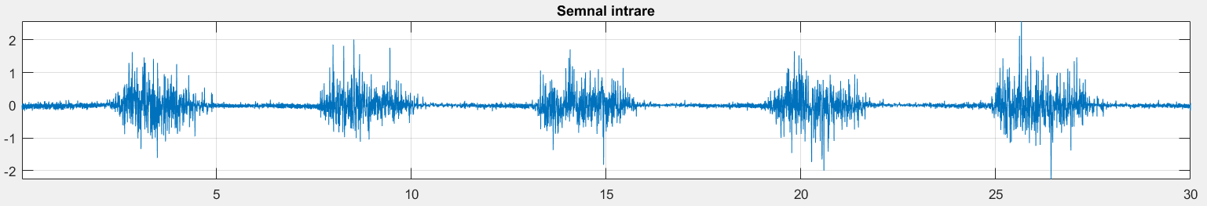

Reesantionare semnal

function s_new = reesantionare (s, fs, fs_new)

len = length(s);

len_new = len / fs * fs_new;

s_new = zeros(1, len_new);

s_new(1) = s(1);

s_new(len_new) = s(len);

for i = 2 : len_new - 1

poz = (i - 1) / (len_new - 1) * (len - 1) + 1;

w = poz - floor(poz); % pondere

s_new(i) = s(floor(poz)) * (1 - w) + s(ceil(poz)) * w;

end

s = reesantionare(s, fs, fs * 5);

fs = fs * 5;

lens = length(s);

t = (1:lens)/fs;

figure(1); subplot(311); plot(t, s); grid; axis tight; title('Semnal intrare reesantionat');

Semnal de intrare reesantionat

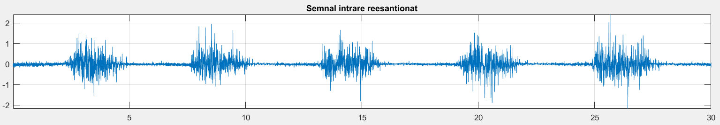

Adaugare zgomot

for i = 1 : 5

disp(i)

procent_zgomot = .2 * i;

zg50 = sin(2 * pi * 50 * t) / 2 * (max(s) - min(s)) * procent_zgomot;

% figure(1); subplot(313); plot(t(1:1000), zg50(1:1000)); grid; axis tight; title('Zgomot 50 Hz');

szg50 = s + zg50;

figure(1); subplot(312); plot(t, szg50); grid; axis tight; title(['Semnal cu zgomot 50 Hz, ' num2str(procent_zgomot * 100) '%']);

w = waitforbuttonpress;

end

Caz 1

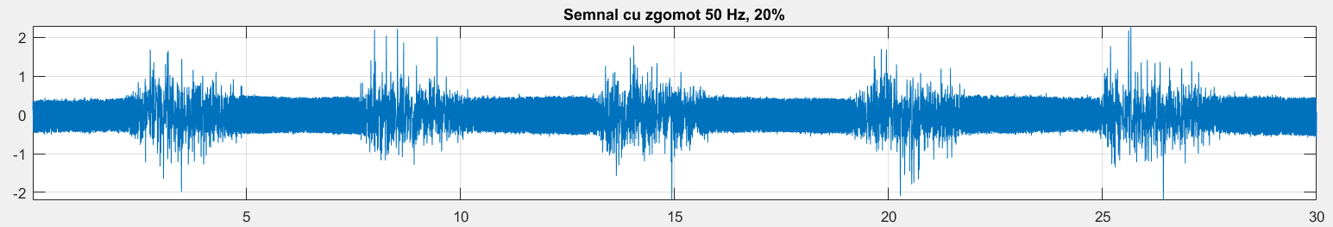

Caz 2

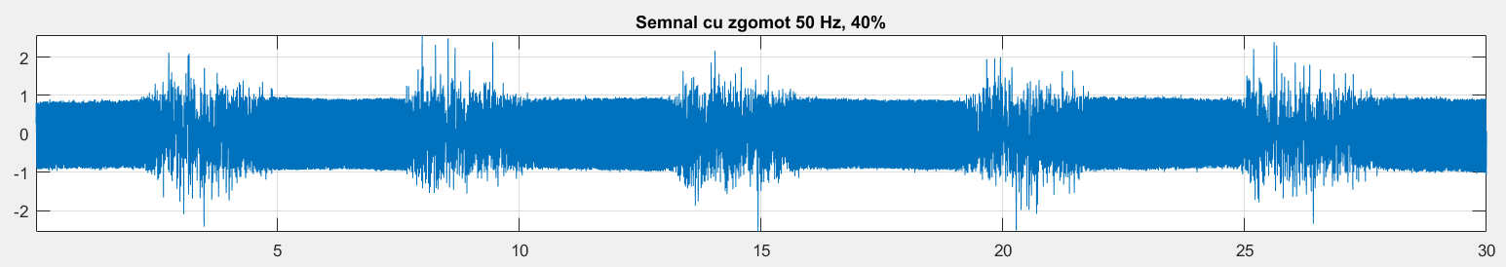

Caz 3

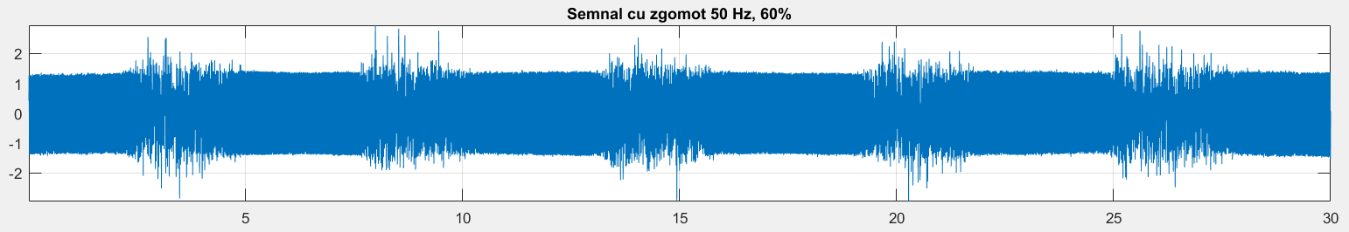

Caz 4

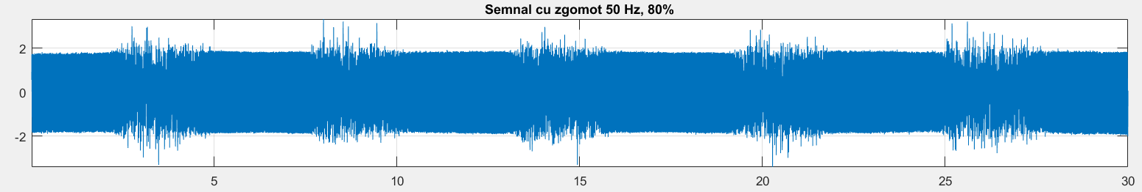

Caz 5

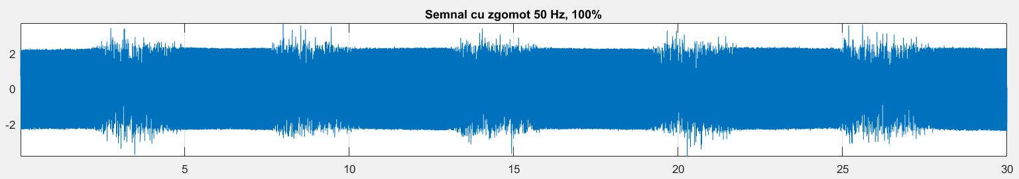

Zgomot Gaussian

Incarcare semnal

[fname, fpath] = uigetfile('*.txt', 'Open EKG, EMG file...');

fid = fopen(strcat(fpath, fname), 'r');

s = fscanf(fid, '%f', inf);

fclose(fid);

s = s - mean(s);

fs=200;

lens = length(s);

t = (1:lens)/fs;

figure(1); subplot(311); plot(s); grid; axis tight; title('Semnal intrare');

Semnal de intrare

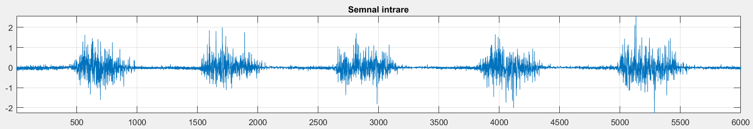

Adaugare zgomot

for i = 1 : 5

disp(i);

putere_zgomot_db = i * 1.5;

szg = awgn(s, putere_zgomot_db,'measured')-1; %Adaugare de zgomot Gauss.

figure(2); subplot(311); plot(szg); grid; axis tight; title('Semnal cu zgomot Gaussian');

figure(2); subplot(312); plot(hist(szg, 100)); grid; axis tight; title('Histograma zgomot Gaussian');

w = waitforbuttonpress;

end

Caz 1

Putere zgomot 1.5 dB

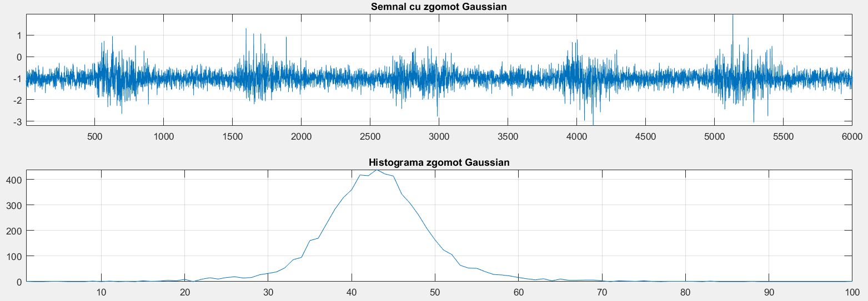

Caz 2

Putere zgomot 3 dB

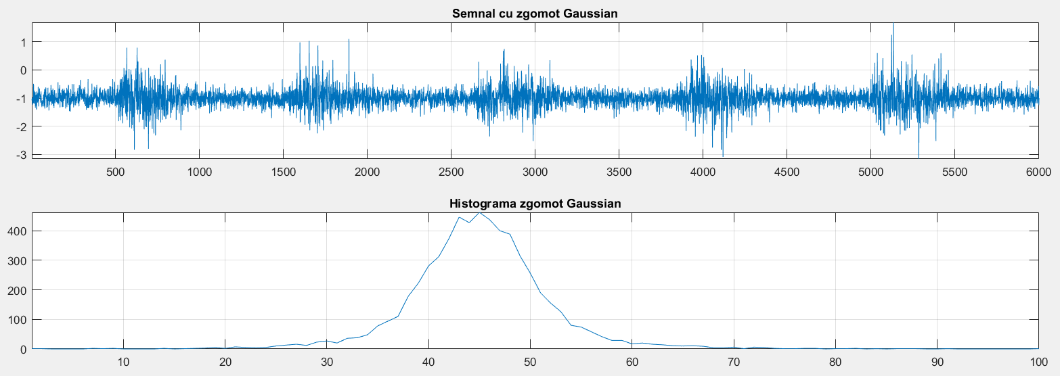

Caz 3

Putere zgomot 4.5 dB

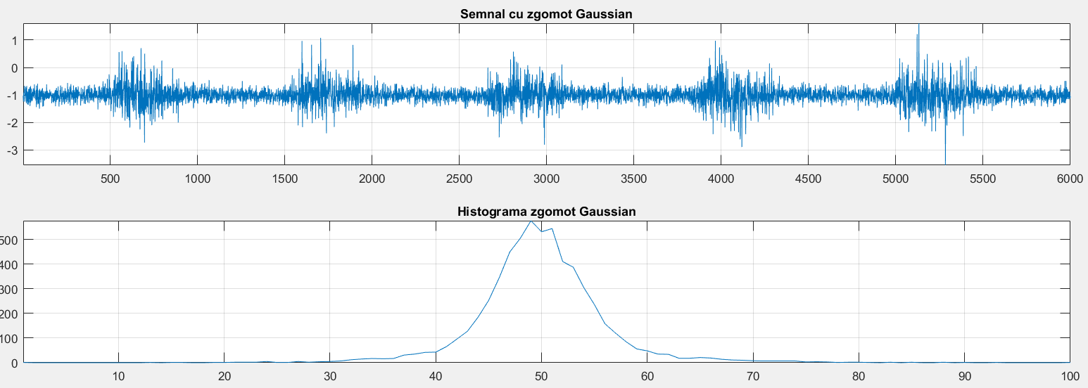

Caz 4

Putere zgomot 6 dB

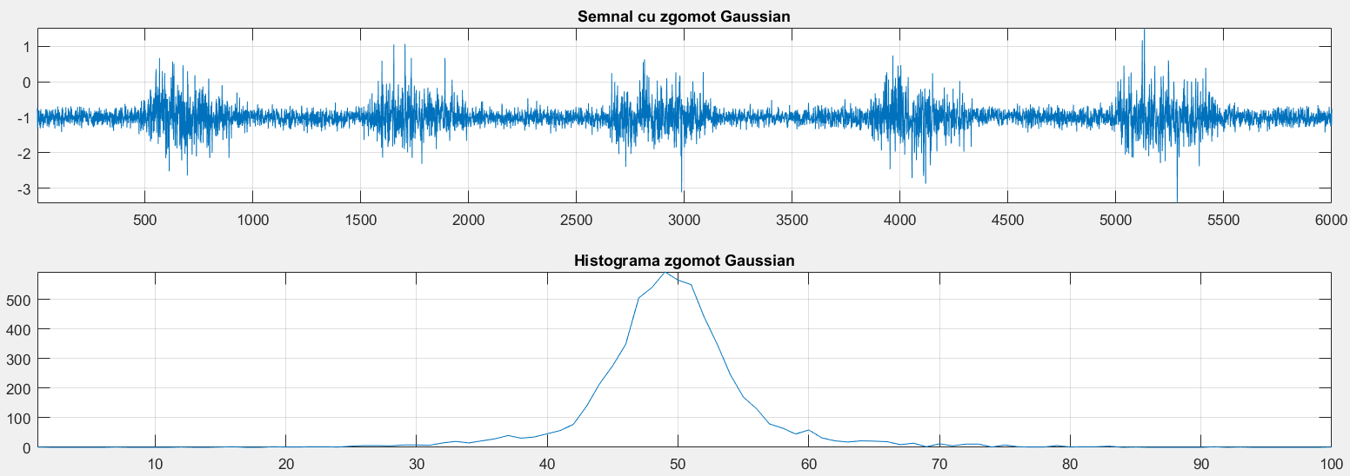

Caz 5

Putere zgomot 7.5 dB

